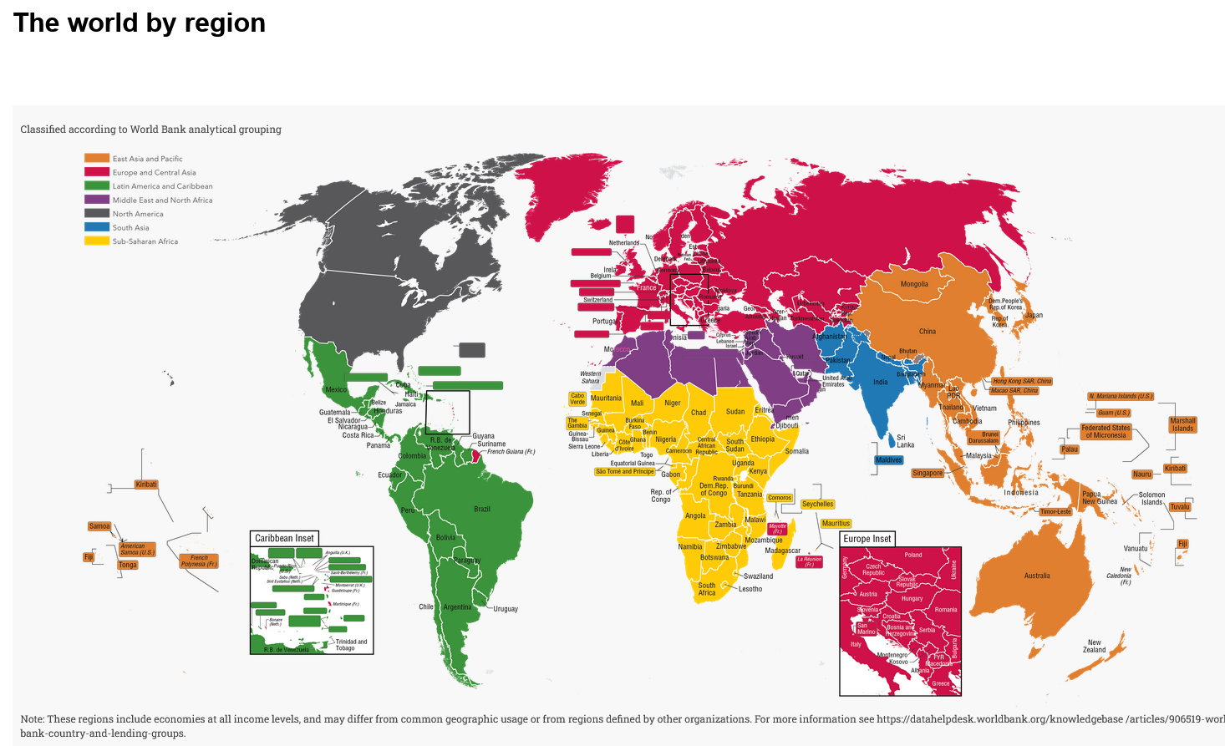
Quelle: https://datatopics.worldbank.org/sdgatlas/archive/2017/the-world-by-region.html

